**SMART CITIES MANHOLE COVER MANAGEMENT SYSTEM BASED ON IOT EDGE COMPUTING**

Dr.P.Sivakumar1, Hemanth R2, Karthik A.K3, Nithish kumar V.R4

*1Professor, Department of Electronics and Communication Engineering, GRT IET College of Engineering,*

*tiruttani District, Tamilnadu, India.*

*2-4UG Scholars, Department of Electronics and Communication Engineering, GRT IET College of Engineering, Tiruttani District, Tamilnadu, India.*

*Abstract*— A smart city is the future goal to have cleaner and better for the society. Smart underground infrastructure is an important feature to be considered while implementing a smart city. Drainage system monitoring plays a vital role in keeping the city clean and healthy. Since manual monitoring is incompetent, this leads to slow handling of problems in drainage and consumes more time to solve. To mitigate all these issues, the system using a wireless sensor network, consisting of sensor nodes is designed. The system also provides a real-time alert to the relevant authorities, enabling them to take immediate action The proposed system is low cost, low maintenance Internet of Things (IoT) devices, and artificial intelligence algorithms based real time which alerts the managing station through an email / message when any manhole crosses its threshold values and to check whether a manhole cap is open or closed . This system reduces the death risk of manual scavengers who clean the underground drainage and also benefits the public.

Keywords: Arduino, Flow sensors, Manhole management, Smart cities, IOT.

I.INTRODUTION

An integral part of any drainage system is the access points into it when it comes to cleaning, clearing, and inspection. Metropolitan cities have adopted underground drainage system and the city’s municipal corporation must maintain its cleanliness. If the sewage maintenance is not proper, ground water gets contaminated causing infectious diseases. Blockages in drains during monsoon season, causes problems in the routine of the public. Hence, there should be a facility in the city’s corporation, which alerts the officials about blockages in sewers, their exact location. It mainly acknowledges in the field of alerting the people about the gas explosion, increase in the water level and the temperature level. It uses IoT to make the drainage monitoring system in a highly automotive by using sensor for detecting and sending alerts through GSM to the authorities.

This project overcomes the demerits by detecting drainage water blockage by installing water flow rate sensors at the intersection of nodes. When there is a blockage in a particular node, there is variation in the flow of drainage water which when cross the set value will display the alert in the managing station. Also other demerits are solved by detecting temperature variations inside the manhole and alerting the same to the managing station. Also, flow rate sensors are used to detect the over flow of the drainage water and alerting the same to the managing station through automatic message.

1. ***Embedded system implementation***

An embedded system is one kind of a computer system mainly designed to perform several tasks like to access, process, and store and also control the data in various electronics-based systems. Embedded systems [1] are a combination of hardware and software where software is usually known as firmware that is embedded into the hardware. One of its most important characteristics of these systems is, it gives the o/p within the time limits. Embedded systems support to make the work more perfect and convenient. So, we frequently use embedded systems in simple and complex devices too. The applications of embedded systems mainly involve in our real life for several devices like microwave, calculators, TV remote control, home security and neighbourhood traffic control systems, etc.

User interface

Embedded system

Output

Hardware

Software

Inputs

Link to other systems

Fig [1]: Overview of embedded system

1. ***SOME OF THE RELATED RESEARCH WORK***

In most of the cities adopted the underground drainage system and it is the duty of managing station to maintain the cleanliness of the cities. If the drainage maintenance is not proper the pure water gets contaminated with drainage water and infectious diseases may spread. If drainage gets blocked and water overflows, manhole lid gets opened which leads toserious issues like fall of vehicles/ pedestrians into themanhole.

1. “Manhole cover intelligent detection and management system” aims at existing problem of manhole cover. Many sensors are setup in the manhole cover to real time monitor its situation, through MCU, RF wireless data communication module and upper computer to analyse and manage manhole cover

2. “Manhole security system” includes a barrier and an alarm. The barrier is dimensioned to fit within a manhole opening and under a manhole cover and alarm system is positioned beneath the barrier and includes monitor devices in the form of sensors with motion detectors to provide a signal if the manhole cover is moved.

3. “Society Cleanliness” To crush these issues by far most of the metropolitan territories accepted underground waste system. Show the fundamental advancement of underground waste structure. If squander gets prevented, it will make various issues, for instance, gridlock, the environment gets foul, and if sewer vent top isn't closed properly there is a chance of occasion of disasters and besides people may get fall into the leakage. Electric power joins are presented underground in the midtown domain taking into account greatness and prosperity of the metropolitan networks. Sewer vent upkeep by human control is amazingly irksome in light of the fact that environment is poor and it is difficult to go inside the sewer vents for evaluating the states of the sewer vents.

**II.LITERATURE SURVEY**

1. **Secure Manhole Monitoring System Monitoring System Employing Sensors And GSM Techniques (2018)**

Nataraja N, Amruthavarshini R, Chaitra N L , Jyothi K , Krupaa N, S S M Saqquaf, Published by: International Research Journal of Engineering and Technology (IRJET) , Present a Opening for manholes due to breakage of manhole cover, manhole explosions are major threat in recent days. Manhole cover opening leads to accidental fall of vehicles, pedestrians leading to accidents or loss of life. Manhole opening detection and alerting is mainly based on detecting the manholes which are opened due to overflow of sewage / rain water during heavy rainfall and alerting. When a manhole opening is detected either due to overflow of sewage water, increase in pressure or temperature, it leads to the breakage of the manhole lids. To avoid such incidents even before it could affect the public, an alerting system is built wherein the buzzer alerts the surrounding and sends the sensed data to the managing authorities using GSM techniques. So, they can take precautionary action to close the manhole considering public safety.

1. **IOT Baased Automation Manhole Detection(2021)**

Dr.T.Menakadevi , Akash.M , Dilip kumar , Kannan.M , Chandra Mohan.S .Published by: International Research Journal of Engineering and Technology (IRJET) ,Smart underground infrastructure is an important feature to be considered while implementing a smart city. Drainage system monitoring plays a vital role in keeping the city clean and healthy. Since manual monitoring is incompetent, this leads to slow handling of problems in drainage and consumes more time to solve. To mitigate all these issues, the system using a wireless sensor network, consisting of sensor nodes is designed. The proposed system is low cost, low maintenance IoT based real time which alerts the managing station through an email when any manhole crosses its threshold values.

1. **Man Hole Detection and Monitoring System Using IOT(2021)**

Mr.ManeHarshavardhan Vijay ,Mr.Nimbaler Swap nil Sanjay , ChougulePushpraj Babaso , Mr.Ghatage Abhishek Dundappa , Ms.Saundatte M .G presents Today situation is very critical for Municipal party to handled this situation our project is very useful to municipality by this project work of the municipality make very easy and smooth Li environmental condition is not good today's suddenly rain is come and level of drainage is increased buy this some accident is orca then the system is very useful manhole detection and monitoring system using iot by this system we detect the manhole condition and monitoring this without any man this system is based on iot therefore no any physical contact with man.

A Drainage Monitoring System Plays significant amount of role to keeping towns and cities healthy and clean. Most of the manholes are open without any observations that cause accidents. In India many cities adopted emptying underground system because it is vital. All the man-holes don’t seem to be in a position of secure. Many man-holes were in broken condition. With these broken man-holes, there were some probabilities of incidence to accidents within the roads. As result, emptying standing will be checked on daily basis. Irregular inspections may cause overflow, clog emptying systems, and compliments will be payed. So manual monitoring was incompetent and leads for handling slow with issues while emptying it may consume more time. After going research with these issues, we’ve built an IoT based man-hole system that monitors temp, gases, water level. These broken manholes are threat to public safety.

**III.EXISTING METHOD**

Today's drainage systems is not high-tech. So whenever there is blockage it is difficult to figure out the exact location of the blockage. Also, early alerts of the blockage are not received. Hence detection and repairing of the blockage become time consuming. It becomes very inconvenient to handle the situation when pipes are blocked completely and garbage cleaning. Due to such failure of drainage line and overflow of garbage people face a lot of problems.

Send the data (output) to the user via web or mobile application using internet

***A.Drawbacks:***

* No Automation is available
* Need internet access
* Monitoring of drainage manually is difficult

In The following are some of the disadvantages of existing method for sending the output of the sensors which used in manhole detection system via text message to user, then we need to initialize the user’s mobile number in previously. But we cannot sure that user always have the registered mobile number. When we consider the second method, it always needs a router and Internet access on both device side and user side. This will increase the initialization and maintenance cost of this system. If the user does not have internet access in his mobile, then he cannot get the updates of the manhole detection system. This is the main drawback of this system.

**IV.PROPOSED METHOD**

In the proposed method, development of IoT based drainage and manhole monitoring system is designed. This system monitors temperature, manhole lid position whether it will opened or close. Maximum levels are set and sensors keep monitoring the changing conditions. As the levels reach a maximum set point the sensors detect and send the signal to controller, where it commands the IoT network to generate alerts to the “Municipal Corporation”. Gas sensor will monitor the toxic gases, Flow sensor will detect the Flow rate of the manhole water, hence the water flow blockage also easily detected. DHT11 sensor will monitor the Temperature and humidity. If any of the sensor data increases greater than threshold value then GSM (Global System for Mobile communication) will send the message to Municipal Corporation and buzzer will give alerts.

In This proposed solution user doesn’t need to have internet access in his device to get update from this manhole Monitoring & detection system

**V. BLOCK DIAGRAM**

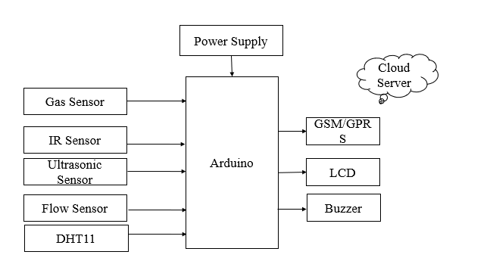

Fig [2]: Block Diagram for manhole monitoring system

**VI.HARDWARE REQUIREMENTS**

***ADUINO:***

The Arduino Uno R3 is a microcontroller board based on a removable, dual-inline-package (DIP) ATmega328 AVR microcontroller. It has 20 digital input/output pins (of which 6 can be used as PWM outputs and 6 can be used as analog inputs). The software used for Arduino devices is called IDE (Integrated Development Environment). It can be programmed using C and C++ language.

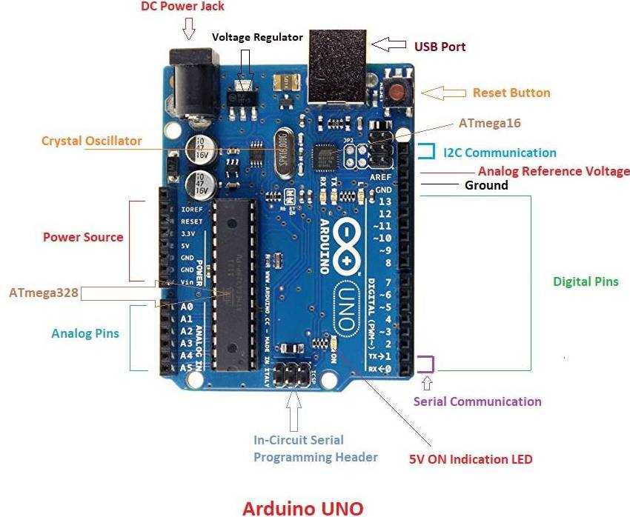

*Fig [3]*: Arduino UNO

***FLOW SENSOR:***

A flow sensor is a component that measures the flow of a fluid such as a gas or liquid. Flow sensors utilize both mechanical and electrical subsystems to measure changes in the fluid's physical attributes and calculate its flow.



*Fig [4]*: Flow sensor

***GAS SENSOR / MQ2 sensor:***

The MQ-2 is a smoke and combustible gas sensor from Winsen. It can detect flammable gas in a range of 300 - 10000ppm.

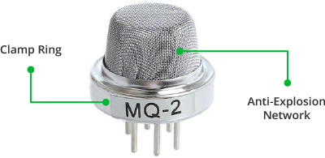

*Fig[5]*: MQ2 sensor

# *GSM/GPRS Module:*

# A GSM module or a GPRS module is a chip or circuit that will be used to establish communication between a mobile device or a computing machine and a GSM or GPRS system.

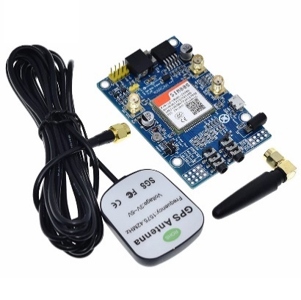

*Fig [6]*: GSM/GPRS Module

***DTH11 Sensor:***

measuring humidity and temperature values in heating, ventilation and air conditioning systems. Weather stations also use these sensors to predict weather conditions.

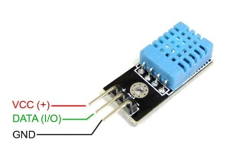

*Fig [7]:*DTH11 Sensor

**VII.SOFTWARE REQUIREMENTS**

**Arduino IDE:**

**Arduino IDE**where IDE stands for Integrated Development Environment – An official software introduced by Arduino.cc, that is mainly used for writing, compiling and uploading the code in the Arduino Device. Almost all Arduino modules are compatible with this software that is an open source and is readily available to install and start compiling the code on the go.

**CONCLUSION**

The Manhole monitoring needs to be cleaned when it is filled to maintain a hygienic environment. Our manhole monitoring system contains Arduino, Ultrasonic sensor, IR. The system monitor the manhole level and it reaches the particular level it sends the notification and if manhole is open then notification alert. This notification system helps the municipality to monitor the opening of manholes. If the drainage wastes are not cleaned it sends the message to higher authority. Our model overcomes the entire problem in smart manhole alert.

**REFERENCES**

[1] S Sultana, A Rahaman, AM Jhara, AC Paul “An IOT Based Smart Drain Monitoring System with Alert Messages”-Conference on Intelligent, 2020 Springer.

[2] A Pendharkar, J Chillapalli, K Dhakate, “IoT Based Sewage Monitoring System”, Available at SSRN, 2020, researchgate.net. ss

[3] U Andrijašević, J Kocić, V Nešić, “Lid Opening Detection in Manholes” 2020 - ieeexplore.ieee.org.

[4] P Bhosale, “Iot Based System for Detection of Sewage Blockages”, 2021, it-in-industry.org.

[5] M Aarthi, A Bhuvaneshwaran, “Iot Based Drainage and Waste Management Monitoring and Alert System for Smart City”- Annals of the Romanian Society, 2021 - annalsofrscb.ro.

[6] Prof S. A. Shaikh1, Suvarna A. Sonawane2, ”Monitoring Smart City Application Using Raspberry PI based on IoT” International Journal of Innovative Science, Engineering & Technology, Vol 5 Issue VIL, July 2017.

[7] Prof Muragesh SK1, Santhosha Rao2, “Automated Internet of Things For Underground Drainage and Manhole Monitoring Systems For Metropolitan Cities.” International Journal of Innovative Science, Engineering & Technology, Vol. 2 Issue 4, June 2015.